Tree Search

BFS

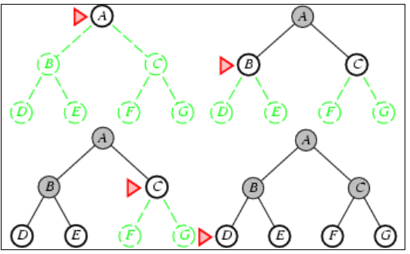

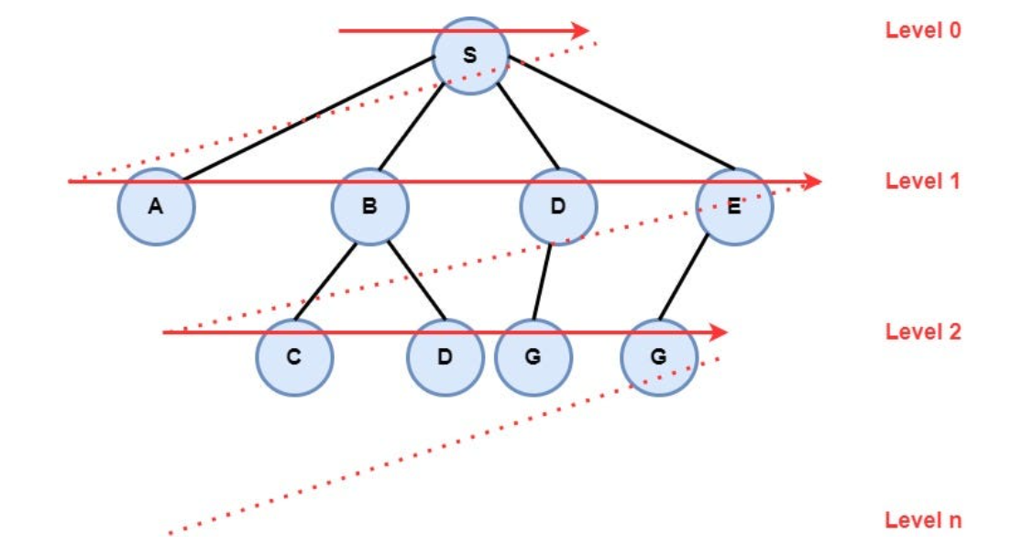

graph = { "A": ['S'], "B": ['C', 'D','S'], "C": ['B', 'J'], "D": ['B', 'G', 'S'], "E": ['G', 'S'], "F": ['G', 'H'], "G": ['D', 'E', 'F', 'H', 'J'], "H": ['F', 'G', 'I'], "I": ['H', 'J'], "J": ['C', 'G', 'I'], "S": ['A', 'B', 'D', 'E'] }

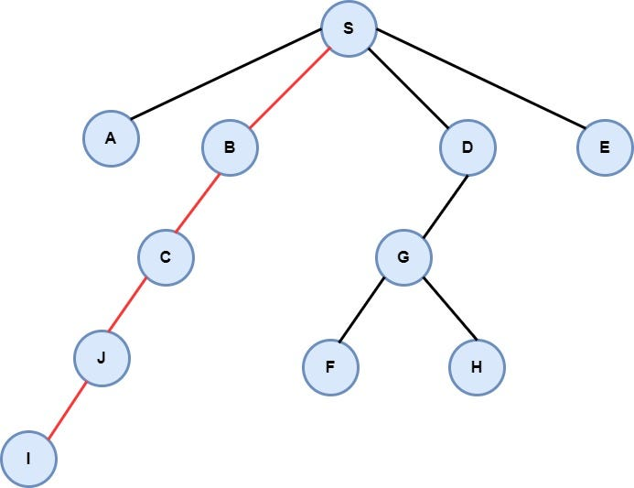**The path from node S to node I**